Decide Meal

1. Introduction
- Decide meal is a website for users that are unable to decide a meal to cook.
- Decide meal generate a random meal for the user to prepare with instructions on preparation with ingredients list and followed by a video instruction on the website

2. User Interface Design and Prototype
- Decide Meal UI consists of a simple 1-click generate a button that will then load a random meal on to the web page.
- The User interface design and prototype using the wireframe is on the next page.
- I have prepared a logo for the decide meal using gimp


img- logo for Decide Meal

3. Navigation Structure
- The website has a navigation bar that includes home, contact, sign-in, and sign-up.
- When clicked the sign-in opens up the sign-in modal and sign-up open sign-up modal.
- The video instruction is playable on the web page.
- If a user does not as the meal generated, he can click on generate again and another meal will be generated.
- The footer contains the social icon for contacting.

4. References
- FreeCodecamp: How to Create a Random Meal Generator by Florin Pop (https://www.freecodecamp.org/news/creating-a-random-meal-generator/)
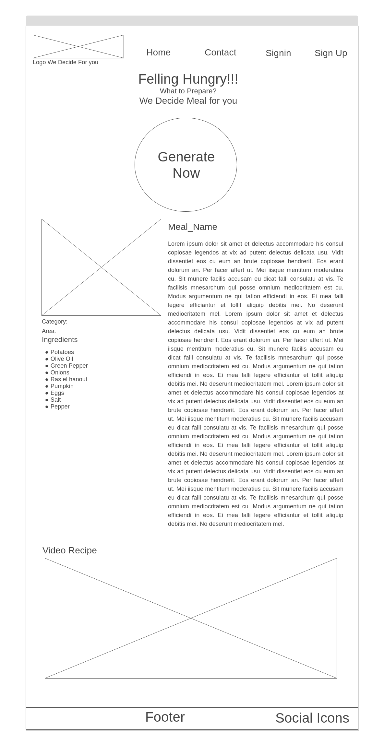
Feeling Hungry!!
Wire frame for Design Meal

